RESPONSIVE PORTFOLIO WEBSITE DOCUMENTATION

Internship: Frontend Developer Intern at ALFIDO
TECH
Task: Task 1 – Responsive Portfolio Website
Developed By: Kullachi Akshaya
Technology Used: HTML5, CSS3, Bootstrap 5,
JavaScript
Hosting Platform: https://akshaya79896-debug.github.io/ALFIDO-TECH-TASK1/

Source Code Repository: https://github.com/akshaya79896-debug/ALFIDO-TECH-TASK1.git

Project Title

Responsive Personal Portfolio Website – A fully responsive personal website designed to showcase my profile, technical skills, projects, and contact information.

Objective
The objective of this project is to create a professional and visually appealing portfolio website that represents my academic background, technical skills, and project work. The website is mobile-friendly and adapts seamlessly across desktop, tablet, and smartphone devices.

Project Description
This portfolio website serves as my personal online presence. It allows visitors, recruiters, and internship evaluators to learn about me and explore my work.
The website includes the following sections:
- Home Section – Introduction and profile summary.
- Skills Section – Programming languages and technologies.
- Projects Section – Featured academic and personal projects.
- Contact Section – Social media links and phone number.
The design is inspired by modern portfolio websites and uses a dark theme with neon green highlights to create an attractive and professional appearance.

Features
- Fully responsive design.
- Fixed navigation bar with smooth scrolling.
- Animated hero section.
- Glowing profile image. • Interactive skill cards.
- Project cards with GitHub and live demo links.
- Social media icons for LinkedIn, Gmail, GitHub, and Instagram.
- Click-to-call phone number.
- Hosted online using GitHub Pages.

Technologies Used Technology Purpose
HTML5 Structure of the website
CSS3 Styling and animations
Bootstrap 5 Responsive layout and components
JavaScript Bootstrap interactivity
Google Fonts Typography
Bootstrap Icons Social media icons
Git & GitHub Version control and source code hosting
GitHub Pages Live Deployment

Project Structure
portfolio-website/ │──index.html
│──style.css
│── profile.jpg
│── cv.pdf
│── README.md

SCREENSHOTS
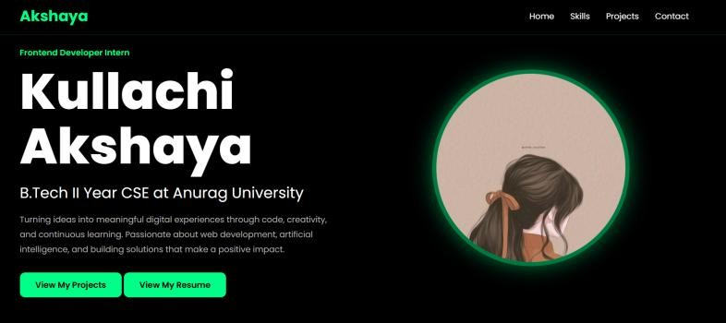
1.HOME SECTION

2.SKILLS SECTION
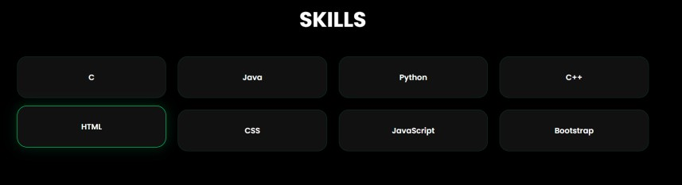

3.PROJECTS SECTION
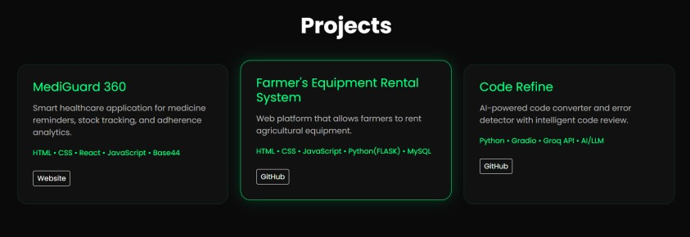

4.CONTACT SECTION
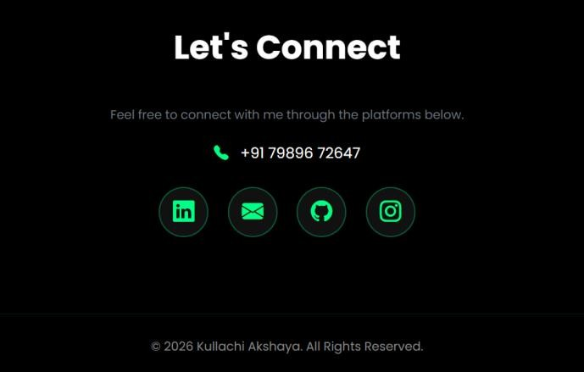

5.MOBILE RESPONSE VIEW
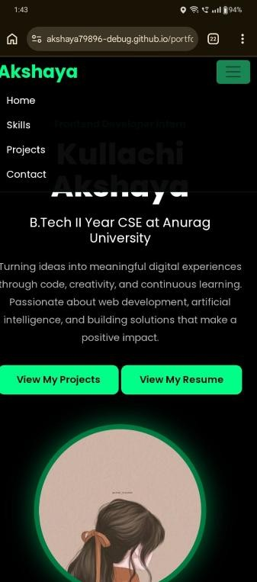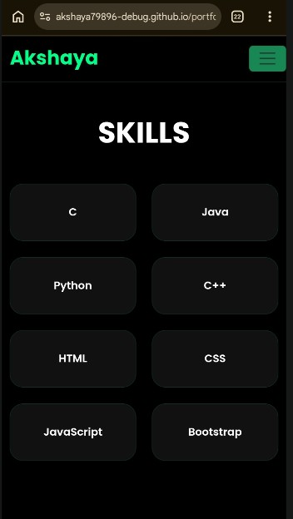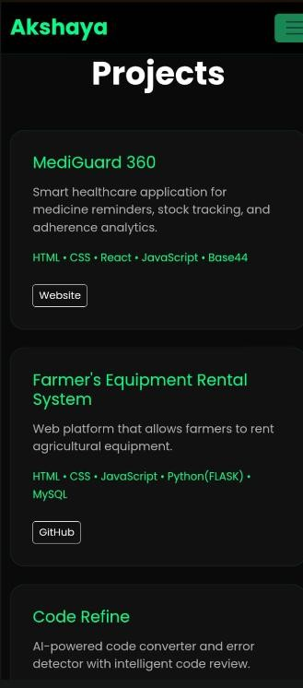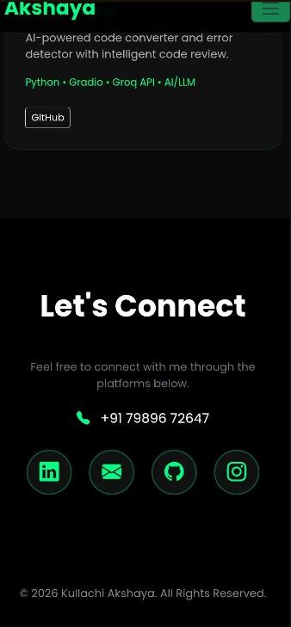

CODE SNIPPETS
1. Navigation Bar (HTML)
<nav class="navbar navbar-expand-lg fixed-top">
<div class="container">
<a class="navbar-brand" href="#home">Akshaya</a>
<div class="collapse navbar-collapse" id="navMenu">
<ul class="navbar-nav ms-auto">
<li class="nav-item"><a class="nav-link"href="#home">
Home</a></li>
<li class="nav-item"><a class="nav-link" href="#skills"> Skills</a></li>
<li class="nav-item"><a class="nav-link" href="#projects">
Projects</a></li>
<li class="nav-item"><a class="nav-link" href="#contact"> Contact</a></li>
</ul>
</div>
</div>
</nav>
Description:
This code creates a fixed navigation bar with smooth scrolling links to different sections of the portfolio website.

2. Hero Section (HTML)
<section id="home" class="hero">
<div class="container">
<h1 class="hero-title">Kullachi Akshaya</h1>
<h2 class="hero-subtitle">B.Tech II Year CSE at Anurag
University</h2>
<p class="hero-description">
Turning ideas into meaningful digital experiences through code,creativity, and continuous learning.
</p>
<a href="#projects" class="btn btn-neon">View My
Projects</a>
</div>
</section>
Description:
This section introduces the portfolio owner with name, education, description, and call-to-action buttons.

- Skills Section (HTML)
<div class="row g-4">
<div class="col-6 col-md-4 col-lg-3">
<div class="skill-card">Python</div>
</div>
<div class="col-6 col-md-4 col-lg-3">
<div class="skill-card">JavaScript</div>
</div>
</div>
Description:
Bootstrap grid is used to display skills as responsive cards.

- Project Card (HTML)
<div class="project-card h-100">
<h4>Code Refine</h4>
<p>AI-powered code converter and error detector.</p>
<span class="tech">Python • Gradio • Groq API</span>
<div class="project-links mt-4">
<a href="https://github.com/akshaya79896-debug/Coderefine-ai" target="_blank"
class="btn btn-sm btn-outline-light">
GitHub
</a>
</div>
</div>
Description:
Displays project details and provides a GitHub repository link.
5. Social Media Icons (HTML)
<div class="social-icons">
<a href="https://github.com/akshaya79896-debug" class="social-icon">
<i class="bi bi-github"></i>
</a>
<a href="mailto:akshaya79896@gmail.com" class="social-icon">
<i class="bi bi-envelope-fill"></i>
</a>
</div>
Description:
Creates clickable icons for GitHub, Gmail, LinkedIn, and Instagram

6. Hero Title Animation (CSS)
.hero-title {
font-size: clamp(3rem, 8vw, 6rem); font-weight: 800;
animation: zoomIn 1.5s ease;
}

@keyframes zoomIn { from {
transform: scale(0.4);
opacity: 0;
} to {
transform: scale(1); opacity: 1;
}
}
Description:
Adds a zoom-in animation effect when the website loads.

7. Skill Card Styling (CSS)
.skill-card { background: #111; border-radius: 20px; padding: 30px; text-align: center; transition: 0.3s;
}

.skill-card:hover { transform: translateY(-8px);
box-shadow: 0 0 25px rgba(0, 255, 136, 0.18);
}
Description:
Styles the skill cards and adds a hover animation.

8. Smooth Scrolling (CSS)
html {
scroll-behavior: smooth;
}
Description:
Provides smooth scrolling when navigation links are clicked.

Commands Used
- git init
- git add
- git commit -m "Initial portfolio website"
- git branch -M main
- git remote add origin https://github.com/akshaya79896debug/portfolio-website.git
- git push -u origin main
Description: These Git commands were used to initialize the repository, commit the project files, and upload the source code to GitHub.

GitHub Repository Link
https://github.com/akshaya79896-debug/ALFIDO-TECH-TASK1

Live Hosted Website Link
https://akshaya79896-debug.github.io/ALFIDO-TECH-TASK1/

Deployment Process
- Created a public repository on GitHub.
- Uploaded all project files (index.html, style.css, profile.jpg, README.md).
- Committed and pushed the files using Git commands.
- Enabled GitHub Pages from Settings → Pages.
- Selected the main branch and root folder as the publishing source.
- Obtained the live website URL after deployment.

Testing
The website was tested on:
- Google Chrome
- Microsoft Edge
- Mobile devices using browser responsive mode
The website was verified to be fully responsive and functional across desktop, tablet, and smartphone screen sizes.

Learning Outcomes
- Learned how to design a responsive website using HTML, CSS, and Bootstrap.
- Improved understanding of navigation bars, layouts, and styling.
- Implemented animations and hover effects using CSS.
- Used Git and GitHub for version control.
- Deployed a website using GitHub Pages.

Conclusion
The Responsive Portfolio Website was successfully developed and deployed. The project effectively showcases my profile, technical skills, projects, and contact details in a professional and responsive format. This task enhanced my frontend development skills and provided practical experience in website deployment and documentation.

Declaration
I hereby declare that this project was developed by me, Kullachi Akshaya, as part of the Frontend Developer Internship at Alfido Tech.

